**第一周预习作业：**

Q:

Please think over the following question, write down your answers and text me from Xuexitong before the class.

1 Please list the successful cases of introducing Chinese culture and explain why you think they’re great.

2 What do you expect to learn from this class/what are the Chinese culture you would like to tell when you have foreign friends from other cultures?

A:

1.There have been numerous successful cases of introducing Chinese culture around the world.

For example, establishing Confucius Institutes is the successful one of them. Confucius Institutes are nonprofit public educational organizations established by the Chinese government with the goal of promoting Chinese language and culture. They have been established in various countries and they offer Chinese language classes, cultural events, and academic exchanges, which foster cultural understanding between China and the host country.

2.I hope to learn some ways about how to spread Chinese culture and how to let foreigners know China better. And I would like to share ancient Chinese poems with my foreign friends, because the poems show the beauty of Chinese characters.

**第一周课后作业：**

**1.What is cultural awareness?**

It refers to the knowledge, awareness, and acceptance of other cultures and other people’s cultural identities. Specifically, it includes the willingness, ability and sensitivity required to understand people with different backgrounds, and the acceptance of diversity.

2.Why do people lack cultural awareness?

People lack cultural awareness probably because they are so close to their own culture and may not be aware that their patterns of behavior are not universal. So when coming into contact with people from another culture, they may not be aware of the cultural differences and behave according to the norms of their own culture.

3.How to improve your cultural awareness?

First, distinguish between intercultural communication (involving people of different cultural backgrounds) and monocultural communication (involving people of common behavior, language and values). Second, develop respect for cultural differences. Third, be aware that cultural differences usually lie in different cultural values, not just in observable behavior. Fourth, avoid immediate evaluation and don’t use the norms of your own culture to judge the behavior of people from other cultures.

**ethnocentrism 种族中心主义**

Ethnocentrism refers to the behavior or belief that favors the nation, culture, or group to which one belongs, often accompanied by feelings of dislike for other groups. Influenced by ethnocentrism, one usually regards his or her own culture as “more appropriate, natural, correct and good” and regards other cultures as “inferior and abnormal.” So ethnocentrism is very likely to lead to pride in one’s own culture and prejudice against other cultures.

种族中心主义指的是偏袒自己所属的民族、文化或群体的行为或信仰，通常伴有对其他群体的厌恶情绪。在种族中心主义的影响下，人们通常会认为自己的文化“更合适、更自然、更正确、更好”，认为其他文化“低劣、不正常”。 所以，种族中心主义很可能导致人们为自己的文化感到骄傲，对其他文化产生偏见。

International enterprises are important participants in cross-cultural communication.

跨国企业是跨文化交流的重要参与者。

Cultural awareness is important for international enterprises to launch advertisements aiming at the audiences of other countries.

跨国企业在针对其他国家的目标受众投放广告时，文化意识十分重要。

Praising one’s own culture while belittling another culture or celebrating one’s own culture while using another culture as an inferior backdrop is a typical sign of ethnocentrism, which often leads to failure in cross-cultural and international communication.

赞扬自己的文化而贬低另一种文化，或赞美自己的文化而把另一种文化当作低等的衬托，这是典型的种族中心主义，易导致跨文化交际和国际传播的失败。

Ethnocentric people tend to identify with “in-group” people and judge “out-group” people in a negative light.

种族中心主义者倾向于认同“群体内”的人，并以负面的眼光评判“群体外”的人。

Ethnocentrism can be seen as making false assumptions about others based on one’s own limited knowledge and experience.

种族中心主义可以看做是基于自己有限的知识和经验对他人做出错误的假设。

Ethnocentrism is closely related to stereotype since stereotyping is a commonly used practice for ethnocentric people to deal with the unknown or their own ignorance in international communication.

种族中心主义与刻板印象密切相关，抱有刻板印象是种族中心主义者在国际交往中应对未知或自身无知的一种常见做法。

Due to the political, economic and military advantages of the West since modern times, some Western countries used to view other cultures with a condescending attitude.

由于近代以来西方在政治、经济、军事等方面的优势，一些西方国家习惯于以一种居高临下的态度看待其他文化。

**1.What is a stereotype?**

A fixed idea or image that many people have of a particular type of person or thing, but which is often not true in reality.

2.How is a stereotype formed?

Categorization: tending to put every single person or thing into a fixed and known category.

Assumption: making assumptions based on one’s own cultural backgrounds and values, and filtering out the information that is not consistent with their prejudgments.

Ethnocentrism: believing that one’s own culture is more natural, correct or superior than other cultures; tending to consider the behavior of people from other cultures as strange, wrong or inferior.

3.What is the harm of stereotyping?

Stereotyping a culture makes people ignore cultural differences.

Stereotyping is usually based on ignorance, exaggeration, distortion, racism, etc., thus resulting in prejudicial (带有偏见的) attitudes.

Stereotyping affects both the behavior of those who have stereotypical views and those who are stereotyped.

**1.What are out-of-context photos or videos?**

They basically refer to the photos or videos that lack or misstate the context in which events occurred.

2.Why is the Big Air Shougang a good example of urban planning, representing sustainability, frugality, and greenness?

This is because the Big Air Shougang is the first competition venue repurposed from an industrial heritage site in the history of Winter Olympics. It is also the world’s first permanent big air venue for long-term usage, such as for tourism, art exhibitions, and sports events.

3.How can you refute the Western netizens’ false views?

The Western netizens’ false views distorted the fact that the venue is actually built in the site of a former steel plant of Shougang Group. Those big towers are simply cooling towers of the former steel mill. Opposite to the so-called “environmental hazards,” the venue is a good example of urban planning, representing sustainability, frugality, and greenness.

**第二周预习作业：**

Li Ziqi is a Chinese we-media creator who produces and shares many traditional Chinese cultures.

**Traditional craft:** In the video, she makes so many things in hand, sunch as flower crowns, embroidery, an iron heated by a charcoal fire, beautiful Hanfu and art of cutting .

**Rural lifestyle:** The life of Li Ziqi is one real side of traditional Chinese farmers. She farms, picks fruits, enjoys flowers, sewons, picnics, dyes fabrics, etc., all of which truly show the beautiful side of traditional Chinese culture to foreigners.

**Traditional food and Cooking:** Li Ziqi has made many traditional Chinese dishes with her unique and superb skills, including peach blossom dishes, peach blossom rice wine, peach glue white fungus soup, dumplings and more.

**Ancient architecture:** The background of life in the video shows traditional Chinese cottages, rice fields, etc., showing the charm of traditional Chinese farming culture.

**第二周课后作业：**

Q:

Please learn the text video clip of introduction to Chinese cuizine again and design your own must-order menu and must-know menu for your foreign freinds who come to China for the first time.It will be checked during the next class

A:

Hello, my foreign friend, I know it is your first time to order Chinese food. Please be welcome to order food from my menu.

There are many must-know and must-order dishes. The first I want to recommend is fried rice. It is rice mixed with other ingredients and they are all fried together. You can choose what you want to put in the rice. And if you fry the noodles instead of rice, then we have fried noodles. I think fried noodles and rice have really saved a lot of foreigners who are not used to Chinese food. If you like the mixed food, you can go for Malatang. It is a mixture of you favorite vegetables and meat. The chef put things together in very delicious soup. Also dumplings are made in a similar way. They are mixture of meat, vegetables and wrap together in small pieces of dough. As you know, dumplings are really famous in China. But perhaps fried rice and noodles are more popular in foreigners. Small steamed bun, Xiao long bao is also the favorite food for many people. We just put the soup in the very thin piece of dough. There are many tips before taking a bite of the bun. First, cool if down. Then make a hole in the dough and suck out the soup. Then you can enjoy the bun with great content.

So delicious, isn`t it? Have a taste!

**第三周预习作业：**

Please translate the following sentences into English.

1. 一方水土养一方人。 长期以来， 在饮食上也就形成了许多风味。 中国一直就有“南米北面”的说法。

Each place has its own way to support its inhabitants. For a long time,many flavors have been formed in the diet.There is a saying in China that “people have wheaten food in north and rice in south”.

1. 中国饮食在口味上主要有巴蜀、齐鲁、淮扬、粤闽四大风味。 本讲中，我们将讲述五湖四海中国菜，带你走近中国的美食地图。

In terms of taste,Chinese food mainly has four flavors: Bashu、Qilu、Huaiyang、Yuemin. In this section, we will introduce Chinese cuisine from all corners of China, and show you a map of famous food in China

1. 面食，是北方人民的最爱。面食的原材料小麦是来自西亚的农作物，易于种植，在干旱的中国北方得到了青睐。北方人民发挥智慧，与小麦的特色完美结合，创造出了数不清的大众化面食种类。

Wheaten food is the favorite of people in the north of China. The wheat, which comes from the west of Asia is easy to live in the dry climate of the north and gain much popularity in northern regions. The northern people give full play to their wisdom and created countless popular wheaten foods, based on the features of wheat.

**第三周课后作业：**

Diverse geographical conditions in China help to form varied way of life in different regions of China. Blessed with the dramatic environment and climate diversity in China, the Chinese people from the desert, the plain, the highland and the sea all obtain energies from the food and try the best to soothe their family members. Each place has its own way to support its inhabitants. For a long time, various tastes have come into being in different regions in China. It has been widely known that people have wheaten food in the north of China and rice in the south. Chinese cuisine can be divided into four flavors of Bashu, Qilu, Huaiyang and Yuemin. In this section, we will introduce Chinese cuisine from all corners of China and show you a map of famous food in China.

**First when talking of the staple food**, the choice of rice or wheat is related to the features of different regions. As a domesticated crop which appeared in the southeast of China, rice have evolved into the top one staple food in China in the past thousands of years. The seed of Chinese rice has started its journey from China’s Yangtze River and spread to all parts of China. Now rice has become the staple food and the 60% of the world’s population. Rice has travelled across the sea and follow people’s footsteps to those distant islands. Wheaten food is the favorite of people in the north of China. The wheat which comes from the west of Asia is easy to live in the dry climate of north and gain much popularity in the northern regions. The north people give full play to their wisdom and create countless popular wheaten foods based on the features of wheat. Among various types of wheaten food, the most representative are dumplings noodles, steamed buns, pancakes and fried dumplings. Even the southern people have created the famous wheaten food such as shao-mai, spring rolls and fried dough sticks. After thousands of years’ competition, rice and wheat finally have negotiations and integrated into each other’s regions and spheres.

**Second, when talking of the flavors**, the cuisine in every region of China has a unique flavor. In Sichuan, the flavor must be the spicy taste. At dusk, the streets in Chengdu are enveloped in the smell of peppers. There are over twenty thousand red oil hot pot stores in the city. The all-inclusive Sichuan food combined the pungent taste of prickly ash and the spicy taste of peppers, which formed a special spicy flavor type. Peppers have been given full play in the hands of Sichuan people. The hot pot, spicy hot pot and chuanchuan which grow out of the Sichuan food now step out of the province and become popular all over the country.

In the northeast of China, the special taste is sour taste. Due to the lack of vegetables, the people there make good use of the local vegetable of cabbage and develop a special delicacy across the four seasons, which is called pickled cabbage. The way of making pickled cabbage is very simple, which is just the adding of salt every other layer before the natural fermentation. Pickled cabbage is in the memory of every inhabitant in the northeast of China. The pickled cabbage, the pickled degree of which is just right turns out to have a sour, tender and crispy taste.

In many parts of the south of China, people’s favorite taste is sweetness. The cuisine from Suzhou is as fresh and delicious as the city itself. The squirrel-shaped mandarin fish is a representative dish of Jiangsu cuisine. It is made of mandarin fish and shaped like a squirrel. It is crispy outside and tender inside, which provides a sour and sweet taste. It ranks among the top ten famous dished of Jiangsu food.

**Next let’s come to talk about the nutrition structure of Chinese food**. Chinese food are mainly vegetables and staple food and is supplement by meat. With the development of living standard, meat has occupied a large percentage in people’s daily food. Among all the meat, pork, fish, chicken and duck are the main meat. Beef and mutton are also popular with a large population. There are various ways to cook meat and the meat satisfy the dual requirements of taste and nutrition. In daily meat food, the braised pork in brown sauce does not have a long history but is the most popular dish in China. Pork and red sauce are very common daily food. The cooking of this dish does not need sophisticated skills but just patience. This helps to make the dish a representative of China’s household dished.

**Let’s move on to the vegetarian diet**. The tradition of eating vegetarian food dated back to the Xia and Shang Dynasty. Many plants and crops have been recorded in the Book of Songs. A pure heart and few desires have been the precondition for ancient saints to practice Buddhism and Daoism. The Buddhists believe that eating a vegetarian diet display a kind heart of not killing animals and a sympathy to all things on earth. Simple vegetarian food is thought to be of much benefits to people’s physical and mental health. Therefore, now over 50 million people in China choose a vegetarian diet.

The life of the Chinese people is warm and there are flavors in their life. The sour, sweet, bitter, spicy and salty tastes are never a taste on people’s tongue but also a deep understanding of life. The Chinese people never draw a demarcation between cuisine and life, which are inseparable to each other in nature.

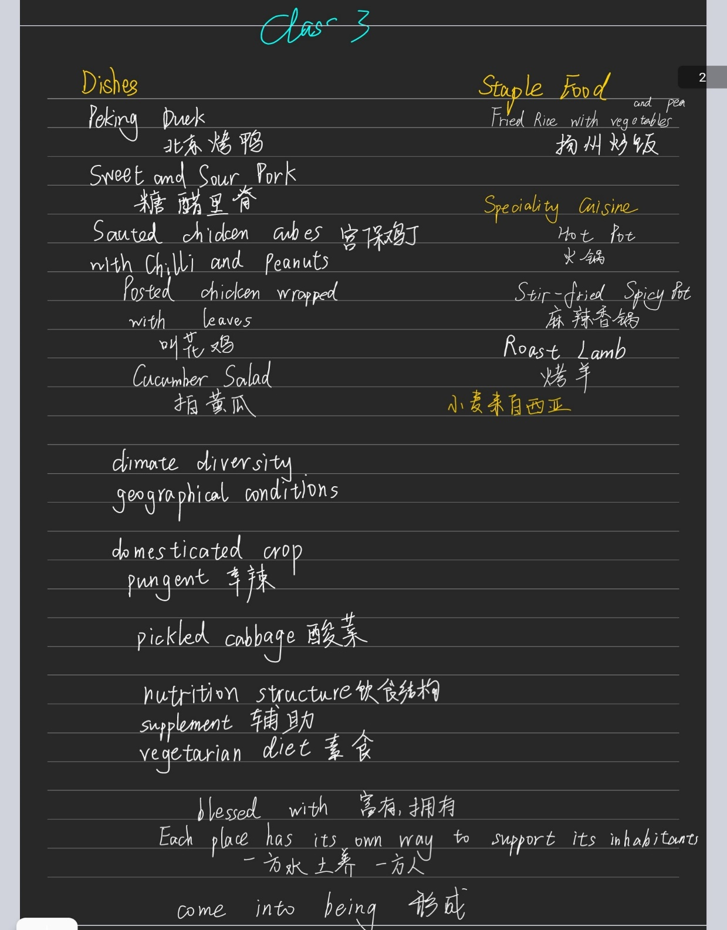

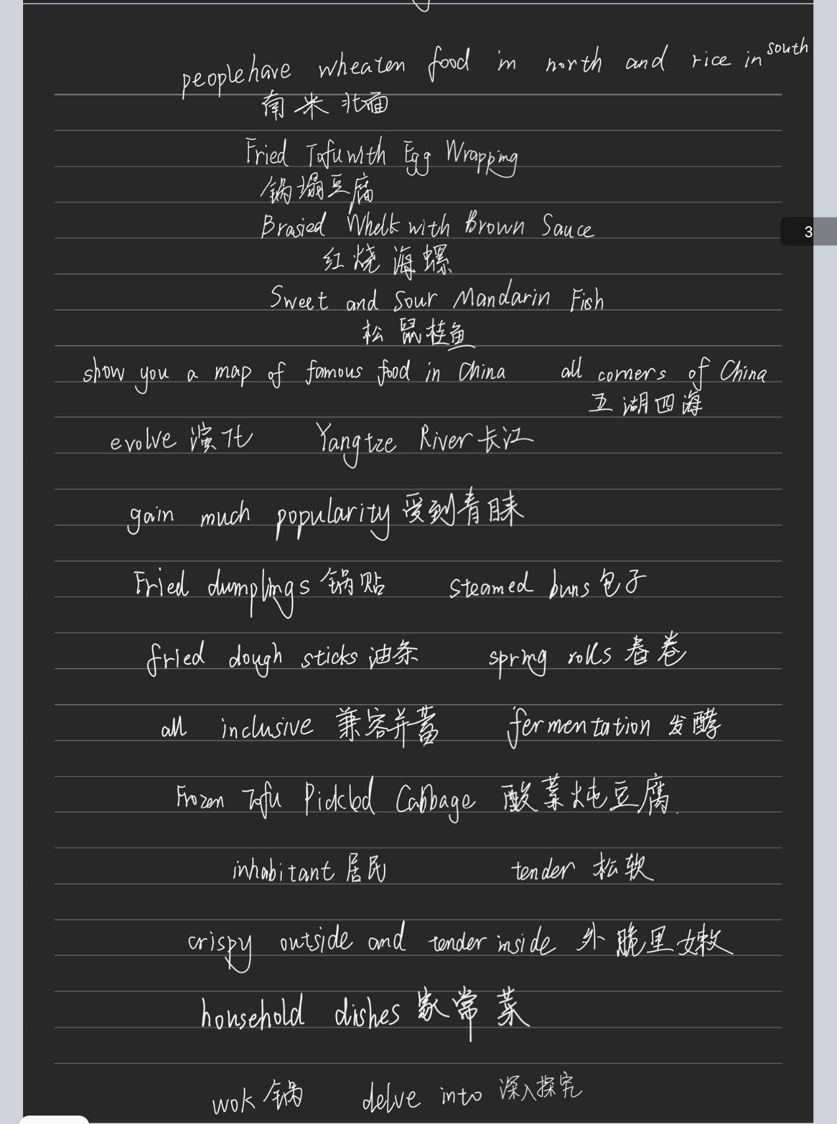

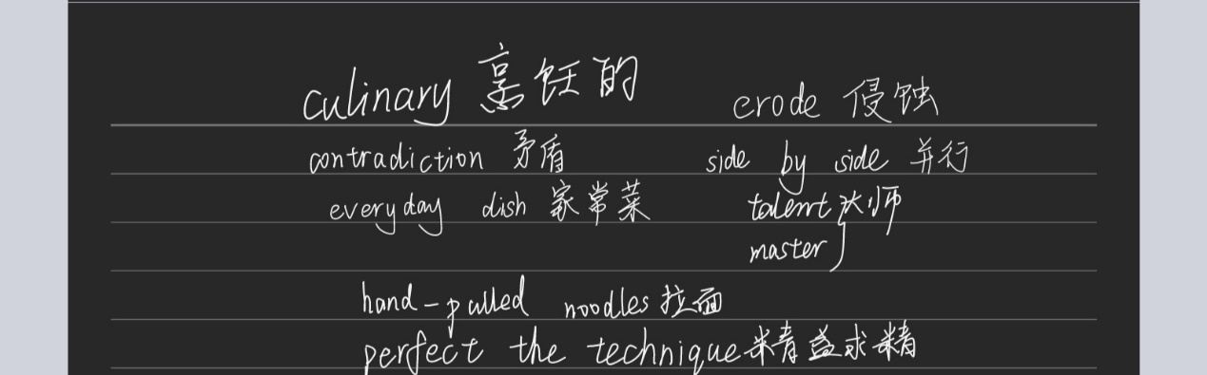

**第四周预习作业：**

Q:

To Finish the rest of BBC: A Culinary Journey, and make comments on the differences of introducing Chinese cuisine between BBC and Chinese text we learned this week.

A:

The BBC focused on various delicacies in Beijing, representing one of Chinese traditional food. It especially introduced local famous food such as noodles, Peking Roast Duck, Beijing dumpling, BBC also combine the food with the daily life of the inhabitants. However, Chinese text mainly introduced Chinese cuisine from all corners of China. It included flavors of bashu, qilu, huaiyang and yuemin. In a word the Chinese text’s content is more extensive, and the BBC’s content have more details.

**第四周课后作业：**

Q:

China, home to one in five of the planet’s population, is the superpower of the world fears, but few really know. Ken Hom is the Godfather of Chinese food. He introduced the wok to the West more than 30 years ago. We are going to take a once-in-a-life adventure across China through food, to delve into its heart and soul. Food is the best way to explore Chinese culture, because we really live to eat. It’s an epic trip, 3000 miles from the megacities of the East to the forgotten villages of the Wild West. We’ll uncover the familiar, the secret and the surprising, cook simple and delicious dishes, and reveal the secrets of China, old and new. It’s like a journey that I’ve always dreamt about.

A:

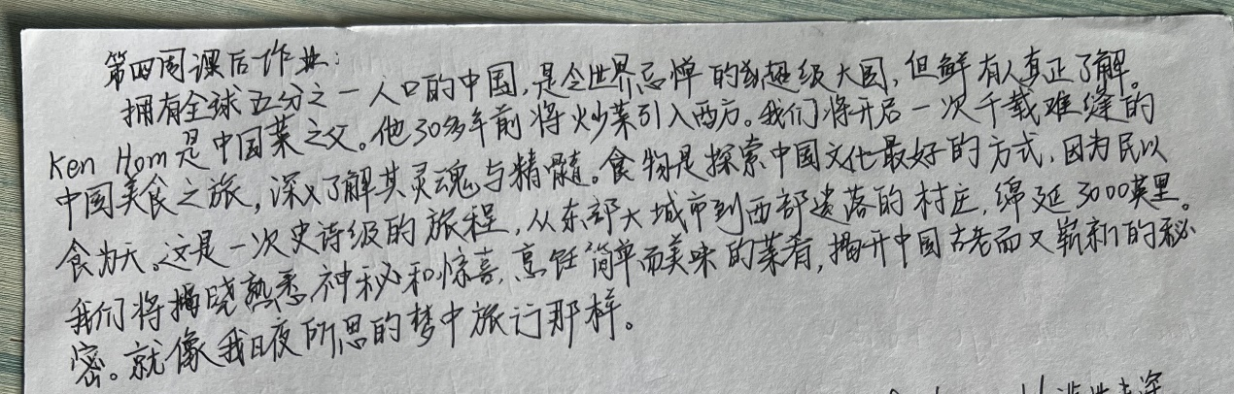

**第五周预习作业：**

Q:

To learn Mulan (Part I) and write down the transaltions of all Chinese idioms and four-word phrases.

A：

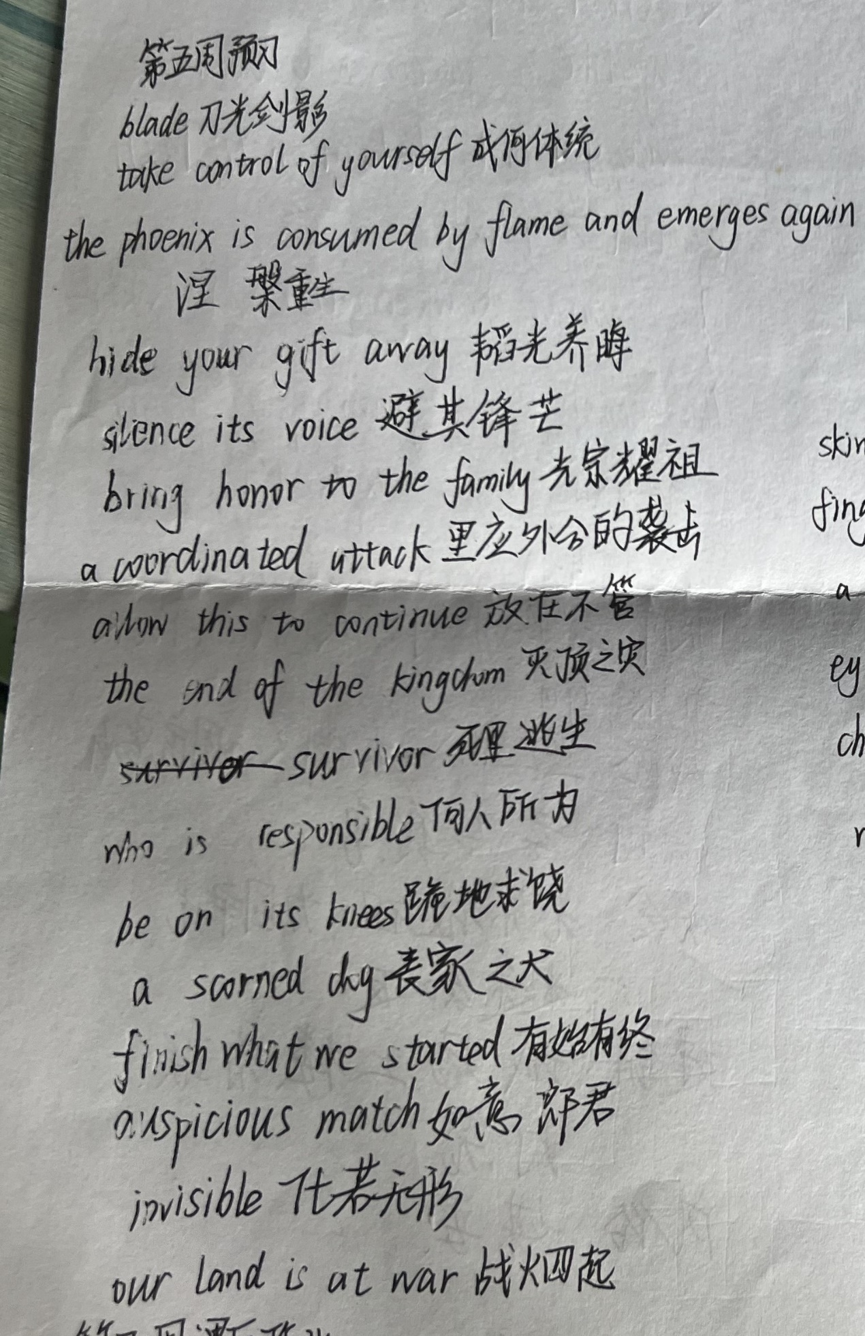

**第五周课后作业：**

Q:

Please finish the rest of Mulan and sum up all the translation of Chinese idioms and the four-word phrases

A:

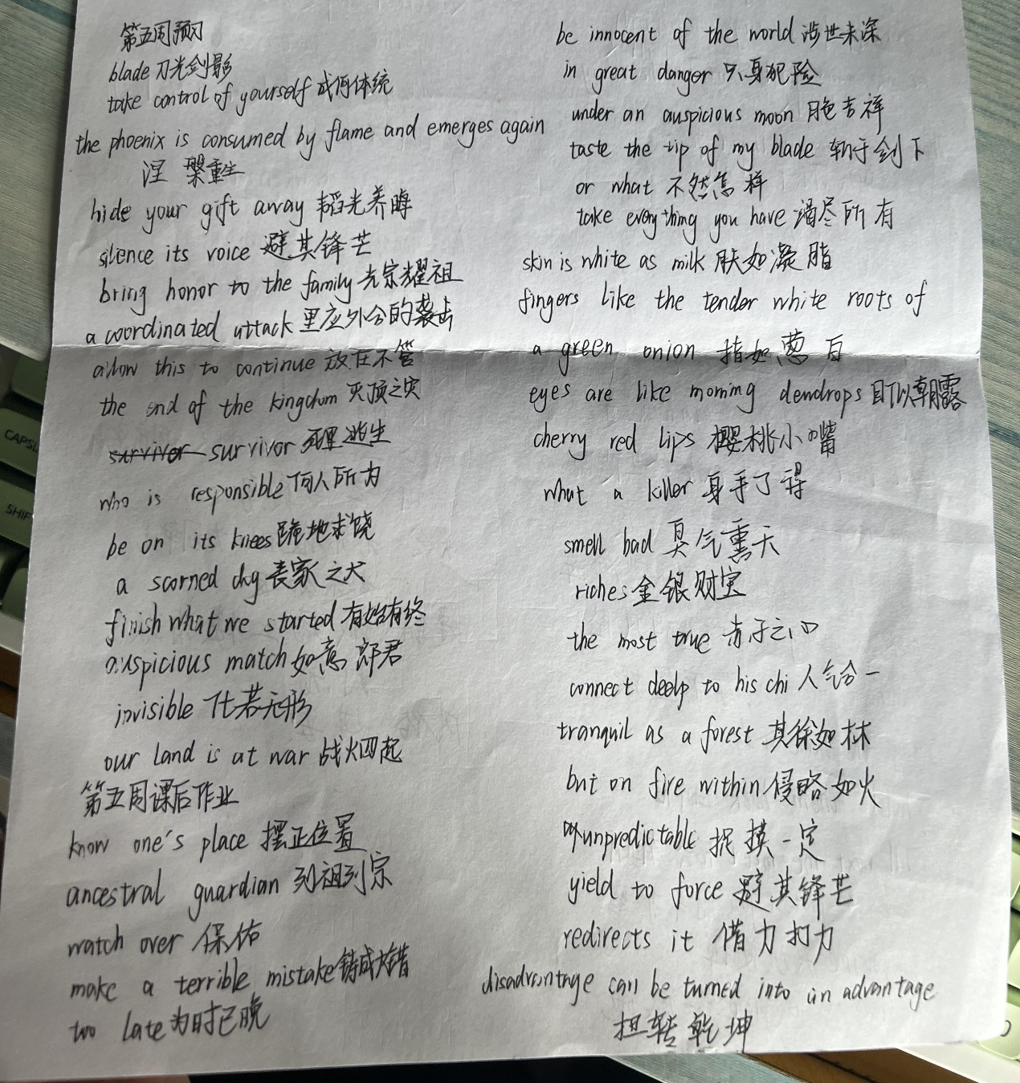

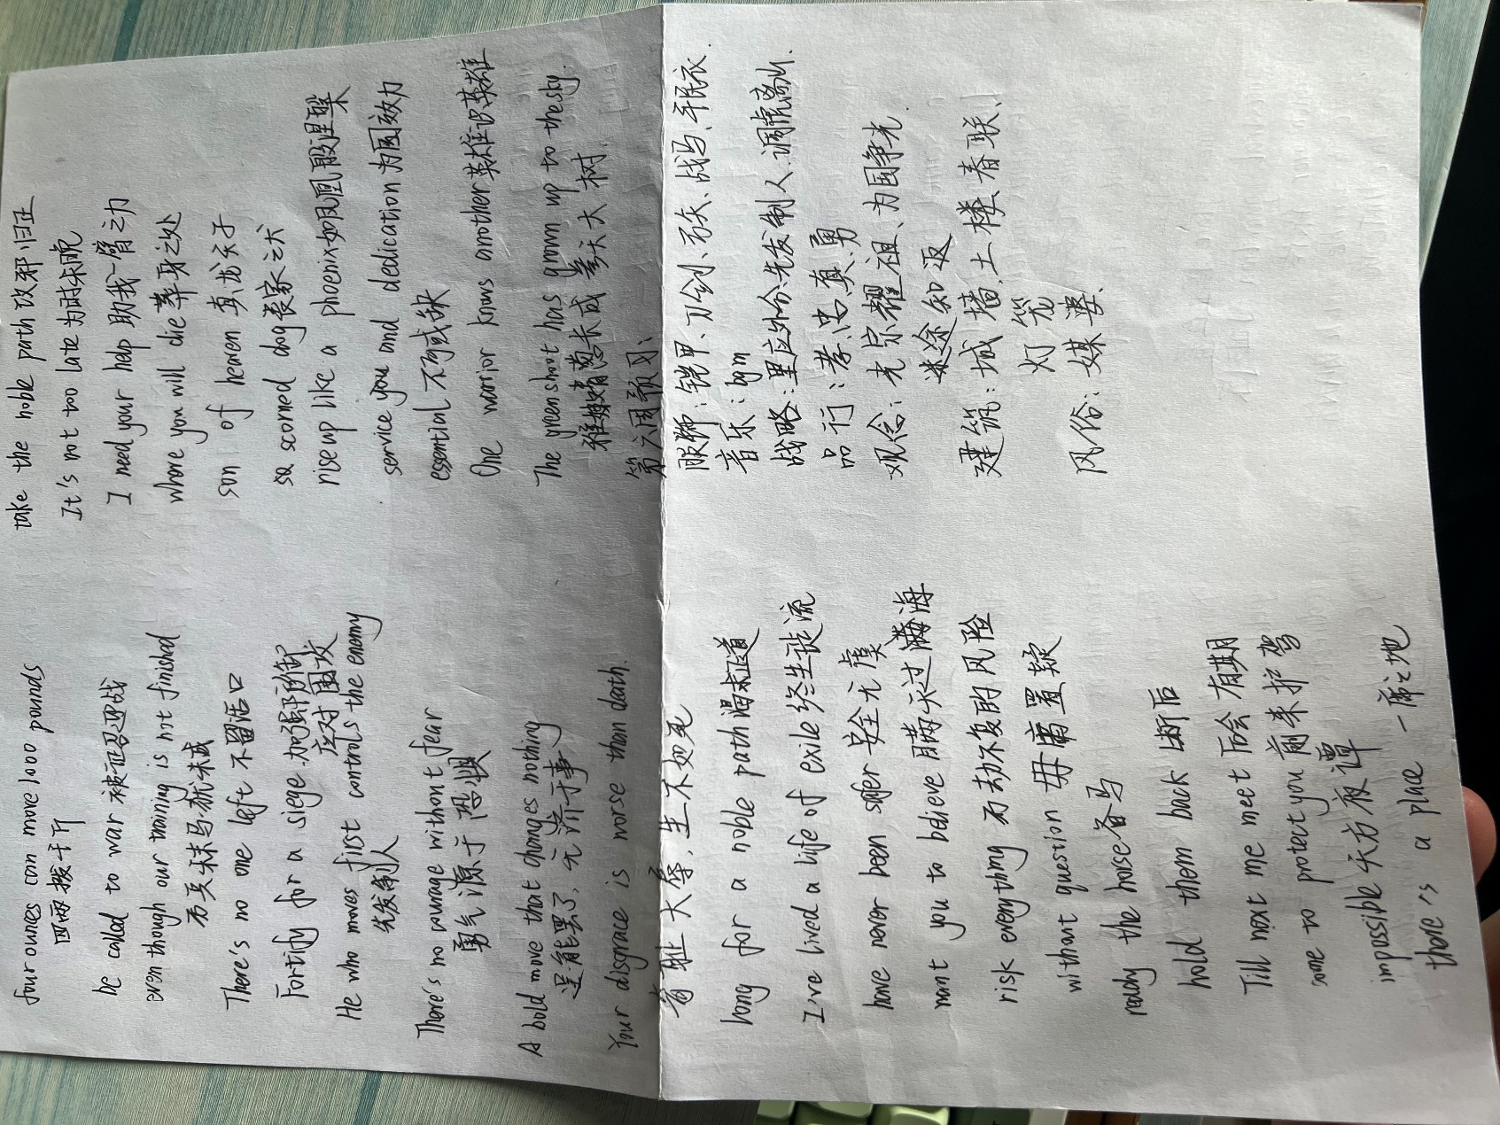**第六周预习作业：**

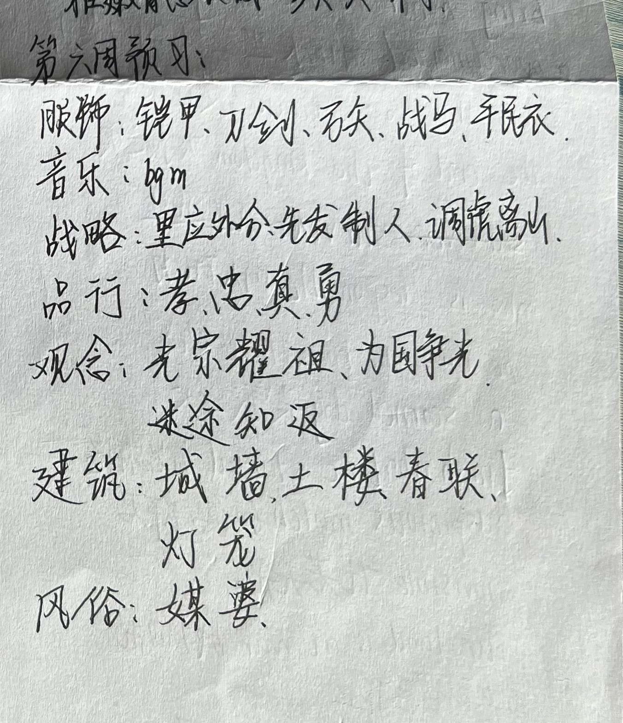

**第六周课后作业：**

Q:

Write a case to introduce the Mid-autumn Festival to your foreign friend who came to China for the first time.

A:

"Hey, I wanted to tell you about a special Chinese festival called the Mid-autumn Festival. It's a time when families come together to celebrate the full moon. People light colorful lanterns, enjoy delicious mooncakes, and share heartfelt stories.

The festival falls on the 15th day of the eighth month in the lunar calendar, usually in September or October. One of the key traditions is gazing at the full moon, a symbol of unity and reunion.

Mooncakes are a must-try during this festival. They come in various flavors and fillings, from sweet to savory. It's common to gift mooncakes to friends and family as a token of love and best wishes.

Chinese folklore is also a significant part of the celebration. The legend of Chang'e, the Moon Goddess, is often told.

So, while you're in China, don't miss the opportunity to experience the warmth and traditions of the Mid-autumn Festival. It's a time of togetherness and cultural richness you'll cherish."

**第七周课后作业：**

Q:

Please make a list of useful words and expressions about Chinese festivals based on the videos frm the class.

A:

Lighter side轻松愉快的一面

Reflection and sadness怀念和伤感

Tomb Sweeping Day清明节

Greenery绿色美景

Commemorate 纪念

Date back to 追溯到

Lavish ceremonies盛大的祭奠

Fallen ancestors先祖

Cold food festival 寒食节

Sacrifice奉献

Give out positions 封官加爵

Receive his reward接受封赏

Wound up to thinking to himself想破脑袋

Get him to come down把他请下来

Miraculously意料之外的

Foolproof天衣无缝

No fire could be set 不许生火

Leave offerings献上贡品